 |  | Economics for Managers  Assignment: Market Power  and Price Discrimination

Make sure to draw the graphs clearly and write sentences that describe the changes you see on the graphs. Also, make sure to show your work on calculations you may make.

- (4 points) Show graphically and write sentences using the information in the graph to show how the price and quantity chosen by a profit-maximizing price searcher will change when the marginal cost curve shifts downward from a constant marginal cost of $40 at all levels of output to $20 at all levels of output. You can pick your own numbers.
MC=40
MC=20

Sentence for Price.
When MC=$40 the price was $65. When the MC shifted downward to $20

Sentence for Quantity.

When MC=$40 the Quantity demanded at a price of $65 was 3.5 when MC=$20 the Quantity demanded at a price of $55 was 4.5

Draw Graph and provide calculations Here.
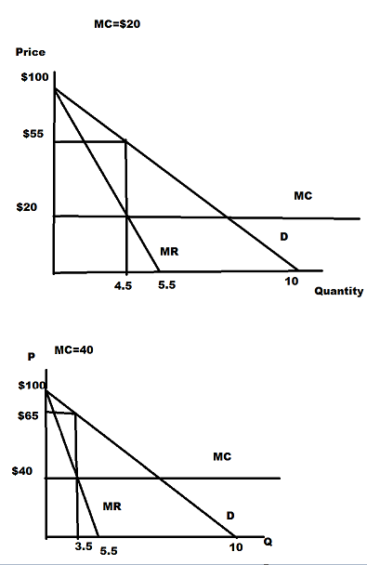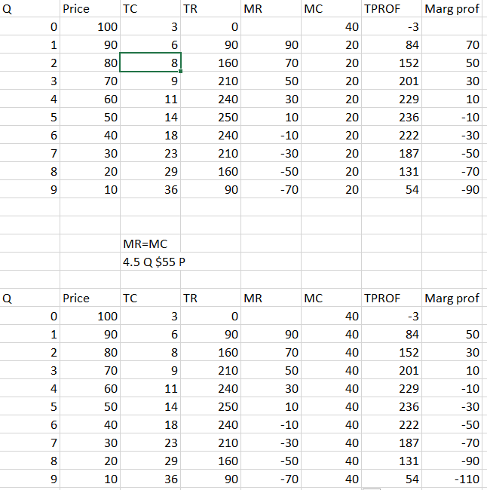

- (16 points). You are a member of the Justice Department. A group of competitive firms in the shoe industry announce that they plan a horizontal merger (a merger of all competitors) that will lead to a monopoly in this industry. Assume that all firms are maximizing profits.
The demand for shoes in this industry is characterized by the following inverse demand function:

P = 1000 – Q.

- Analyze the impact of the merger in a situation where the marginal costs and average costs of producing shoes are $600 per unit for the firms prior to the merger and they remain at $600 per unit after the merger. Show the before and after situations on the same graph and use sentences to describe how the merger will change the following:
- the price of shoes (2 points)
- the quantity of shoes (2 points)
- consumer surplus (2 points)
- producer economic profits (2 points)

Sentences for

Price:
Competition market demand and supply dictate how much can be charged per unit where MC=MR
Monopolist will raise the price and lower the quantity were MC=MR.
In the monopolist market, the Price will move from P1 and raise to P2 while at the same time the quantity will lower from Q1 to Q2.
Quantity:
the quantity will lower from Q1 to Q2.
Consumer Surplus
Under a Monopolist market, consumer surplus will fall area ABCDE to area AB
Producer Surplus (economic profits)
Raise from FH to CDF
Graph and Calculations Here.

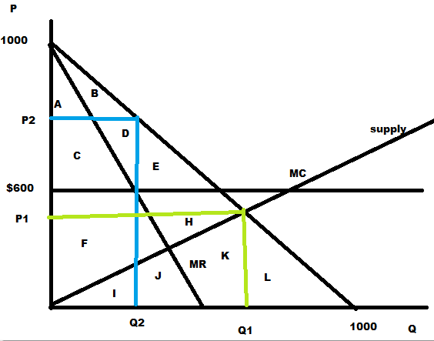

- Analyze the impact of the merger in a situation where the marginal costs and average costs of producing shoes are $600 per unit for the firms prior to the merger and they fall to $100 per unit when the firms are all merged into the single monopoly. Show the before and after situations on the same graph and use sentences to describe how the merger will change the following:
- the price of shoes (2 points)
- the quantity of shoes (2 points)
- consumer surplus (2 points)
- producer economic profits (2 points)

Sentences for

Price:
The price will raise from P1 to P2 under
Quantity:
The quantity will lower from Q1 to Q2
Consumer Surplus:
Consumer surplus will lower from area ABCDE to AB
Producer Surplus (economic profits):
Producer surplus will raise from area FGHKILMN to area CDFGKLM
Graph and Calculations Here.

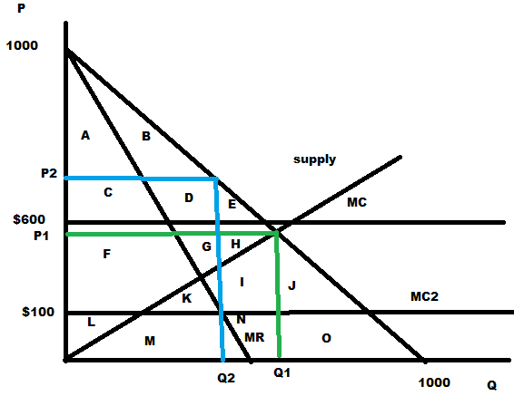

- (20 points) Compare a situation of market competition, monopoly, and monopoly with first-degree *+price discrimination on a single graph. Assume that the firms are maximizing profits. Assume that the supply curve for the competitors is the same as the marginal cost curve for the monopoly situations. Draw the Supply Curve (marginal cost curve) with an upward slope. For the three situations compare
  - the price (or prices) charged consumers (3 points),
  - the quantity sold (3 points),
  - consumer surplus (3 points),
  - producer surplus (3 points),
  - total gains from trade (3 points).
  - In which situations will there be deadweight losses? (2 points)
  - When comparing the single-price monopoly to the first-degree price discriminator, are there any consumers who are better off from the switch to first-degree price discrimination? (3 points)

Graph Here:

Fill in the grid Below
 | Competition | Single Price Monopoly | First-Degree Price Discrimination
i. Price (or Prices)

ii. Quantity sold

iii. Consumer Surplus
iv. Producer Surplus
v. Total Gains from Trade
vi. Deadweight Loss
vii. Better off consumers

